Application Form
NBPA Karin Mulligan
Scholarship Scheme

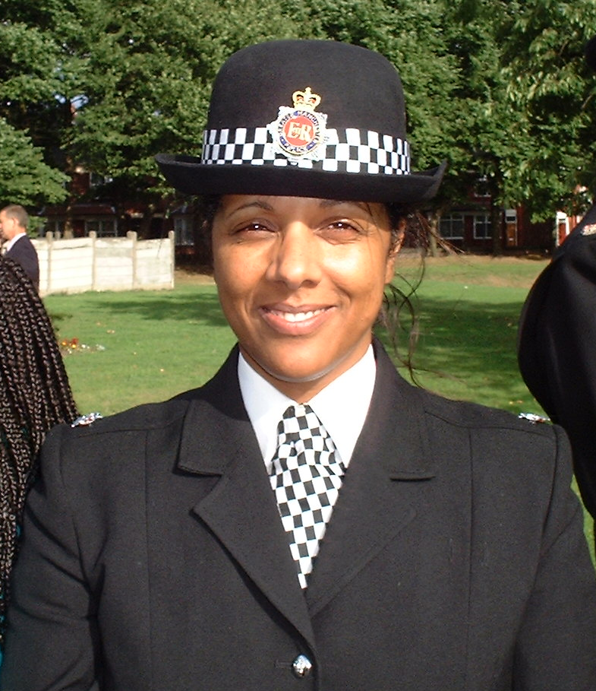
Background

Karin Mulligan one of Britain's most senior black police women died in March 2009 after losing her battle with cancer.

Karin was an exemplary police officer who challenged injustice and discrimination wherever she found it, she earned and deserved the respect and admiration of many, especially the NBPA.
Karin was a 'pioneer' for “Black” women in the police, she died just minutes after being presented with a ‘Policing Excellence Award’ from the National Black Police Association.

Karin supported and guided many, it is in tribute to these endeavours that the NBPA have established a scholarship scheme in her name, “the Karin Mulligan NBPA scholarship scheme”.

The scheme will operate through the NBPA charity and will contribute to the development of members of the community, police officers and police staff completing academic study or personal development linked to policing.

Applicants will receive a maximum sum of £1000.

Applicants must detail the development or study that they wish to undertake.

Applications will be considered twice per year for announcements in March and September.

Who can apply for this scholarship?
In order to be eligible to apply for a scholarship you have to be:
- Permanently reside in the UK or NI
- A established affiliation or relationship with local or national bpa
Please note that bids must be linked to specific courses/development.

Details of successful applicants will be published on the NBPA website

Please note that bids without the necessary information will not be considered.

- Academic/Institution/organisation contact information for candidates wishing to
apply for a Scholarship

- E­mail and/or website address

- Applicants must compete the form below at appendix I
- Please note that the dates for applications to reach the NBPA will be Jan/Feb and June/July each year only. Applications received outside of these dates will not be considered.

Please see guidance notes below for assistance in application completion
Scholarship selection criteria

The applicant must demonstrate some of the below criteria which will be assessed by the panel:-

- Accepts personal responsibility for own decisions and actions in relation to their development
- Displays initiative in relation to this idea
- Takes action to resolve problems and fulfil own responsibilities re development
- Takes pride in own work and professionalism
- Is self motivated, showing enthusiasm
- Project will demonstrate an improvement in professional knowledge or skills
- Is open, honest and genuine
- Makes decisions based upon ethical considerations and personal integrity
- Is flexible and prepared to change their approach to best suit the circumstances
- Understands the need for change and can see the benefits
- Adapts to new ways of working and its demands
- Creates opportunities to learn and develop self or the organisation
- Maintains responsibility for completing tasks within agreed timescales
- Actively develops and progresses career/future career

NBPA SCHOLARSHIP SCHEME – INTERNAL APPLICATION
(Applicants working for a policing organisation)

1. | Name of applicant:  All applicants  Insert a recent colour photo

2. | Name of BPA applicant associated with and how long? :

3. | Development/Courses title: (please include course provider and course contact and date(s):

4. | Total cost of course/development:£___  4a. Total requested from NBPA:£___  4b. Have you applied for other funding for this course? Y/N

5. | Age: (Applicants under 17 must give details of a guardian or parent)

6. | Do you have a disability (in line with DDA 1995): Yes / No

7. | Gender:

8. | Ethnicity:

9. | Religion/belief:

10. | Sexual orientation:

11. | Address:

12. | Academic qualifications (please list all):

Scholarship Schemes.

Applicants Signature and consent:

Parent’s Signature (if applicable):

Date:

12. Institution/organisation contact details for future correspondence with the NBPA

College/university/organisation - Please return this form prior to commencement of the academic year by e­mail or hard copy:
Appendix I
Applicants must complete an A4 single page completed in font Arial 12 explaining why the NBPA should support your application.

- Applicants must detail how they will benefit from the development or how the NBPA will benefit
- And why the course is important to career development
- A full 'picture' of where they are in their career/education

Guidance notes

- The panel has the final say on each award

- The panel will agree which courses the scheme will support

- Monies will be paid directly to the service provider and will not be paid to any individual unless there are exceptional circumstances

- The photograph provided maybe used as part of the scholarship promotional material or on the NBPA website

- All successful applicants agree to participate in promotional material including any awards ceremony or web based information

- All successful candidates agree to provide a written testimony to the NBPA post completion of their training/development

